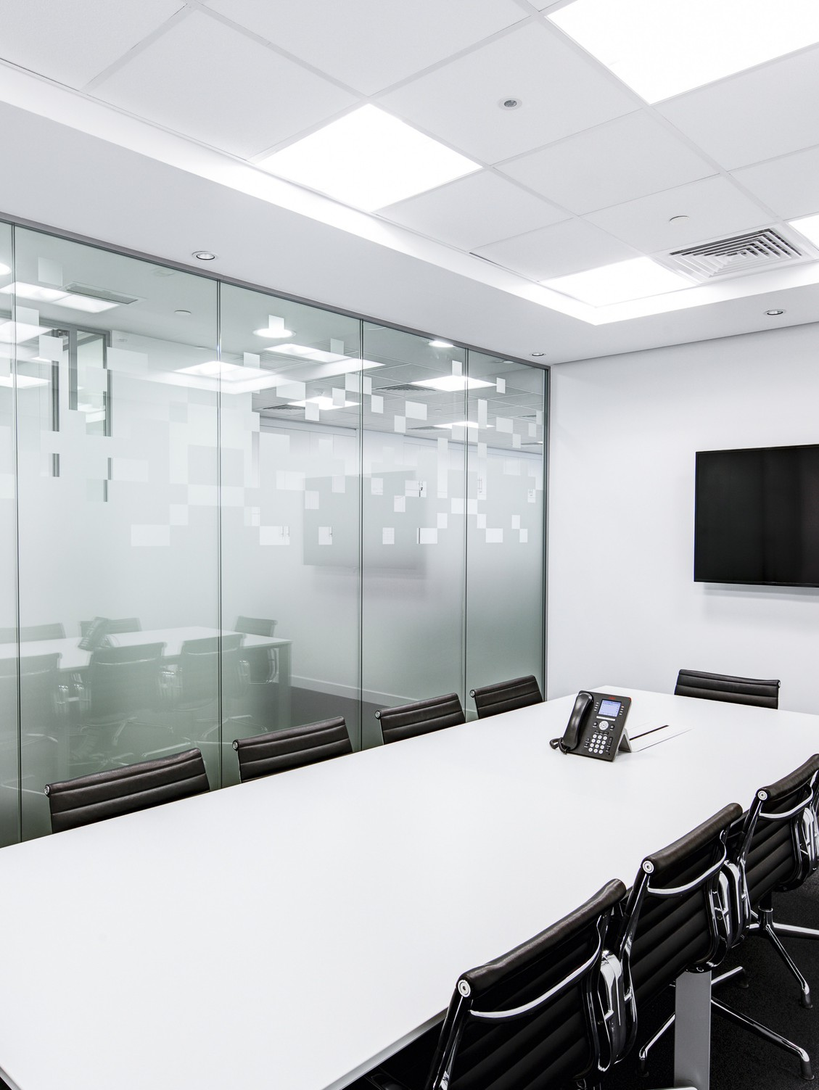



**ANNUAL**

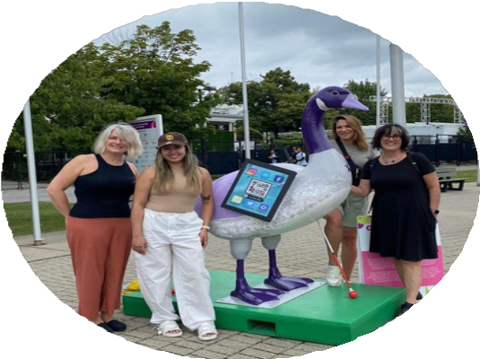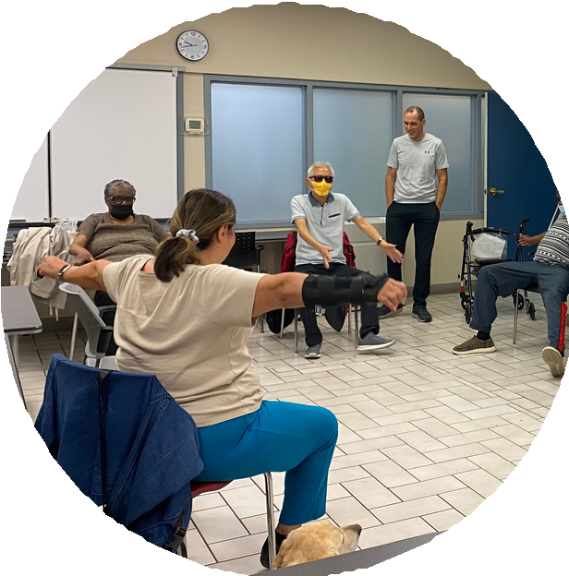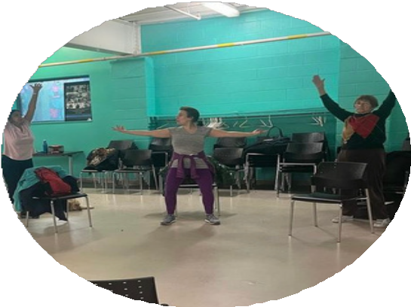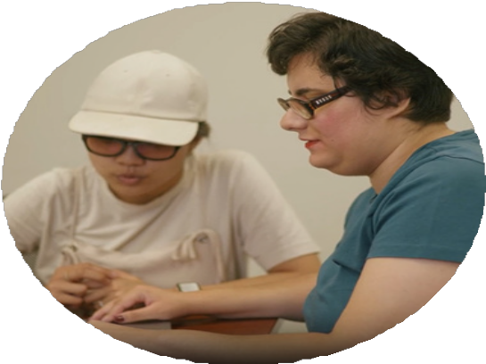

**REPORT**

2023-2024

[info@balancefba.org](mailto:info@balancefba.org)

Table of Contents



M e s s a g e f r o m t h e B o a r d C h a i r a n d C E O 3

V i s i o n , M i s s i o n a n d V a l u e s 5

I m p a c t 6

A s s i s t i v e T e c h n o l o g y P r o g r a m 7

P r e - E m p l o y m e n t P r o g r a m 8

G r o u p s a n d E v e n t s 9

C a n a d i a n N a t i o n a l E x h i b i t i o n G o o s e U p 1 0

B A L A N C E I n f o F a i r 1 1

L o w V i s i o n S p e a k e r S e r i e s 1 2

L i v i n g B l i n d P o d c a s t 1 3

B e c a u s e o f B A L A N C E C a m p a i g n 2 0 2 3 1 4

V o l u n t e e r s M a k e a D i f f e r e n c e 1 5

F u n d i n g P a r t n e r s 1 6

C o m m u n i t y P a r t n e r s 1 7

T h a n k s t o s t a f f , c o n t r a c t o r s , & a p p r e n t i c e s 1 8

B o a r d o f D i r e c t o r s 2 0

C o n d e n s e d F i n a n c i a l s t a t e m e n t 2 1

2 0 2 3 - 2 0 2 4 D o n o r s 2 3

C o n n e c t w i t h u s ! 2 8

2

**Message from the Board Chair and the CEO**

The past year has been a particularly good one for BALANCE for Blind Adults. The ability to stay strong through the pandemic has made it possible for us to emerge from this stressful time a more effective organization, one that responds to the diverse needs of our clients, and makes it possible for us to provide services in new and unique ways.

In the past 8 years, we have grown our service users by 91%! The number of individuals served was 181 in 2023-24, and we had an additional 22 people who came to groups without requesting individual lessons or support. We also brought back our in-person groups and increased the variety of options (see page 06 for more information).

Technology is today’s great key to independence for all of us, including people who are blind. This year, we grew our number of AT Apprenticeships to 5, enabling more tech training to more people in great need. This is an example of how we will support our service expansion priority of more service to more people in 2024-25.

And our United Way funded Pre-employment training program graduated 27 people and trained over 40 staff in 6 community employment services. Moreover, this year we were able to create 16 self-guided video learning units for this program!

All of the above programs and services, and so much more, attracted a record amount, over

$150,000 in donations, sponsorships, and grants in 2023.

The increase in revenue has also assisted us to meet the operational requirements of our new (2022) strategic priority of remote service expansion, about which you will hear more in 2024- 25! We would like to thank all of our supporters for helping to create the [“Bold Future”](https://www.balancefba.org/wp-content/uploads/2023/10/strat-plan-2023-1-1.pdf) outlined in our current strategic plan.

Onwards and Upwards!

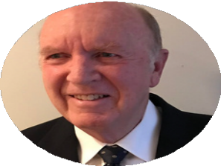

3

Keith Gordon

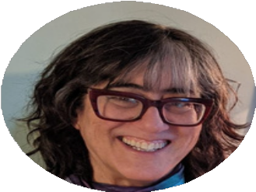

*Board Chair*

Deborah Gold

*Chief Executive Officer*

### Vision Mission and

**Values**

##### *“An open world for persons who are blind or living with sight* loss.”

**Our Values**

**Collaboration** is the Value that underpins all we do:

Our work at BALANCE for Blind Adults is based in a collaborative approach and philosophy. We collaborate with our clients in their learning and rehabilitation; we collaborate with each other as we deliver services; we collaborate with our community partners, donors and funders, to develop programs and services that are grounded in our 5 Core Values:

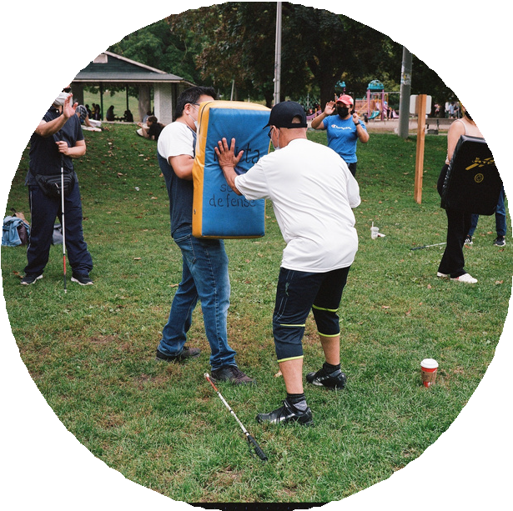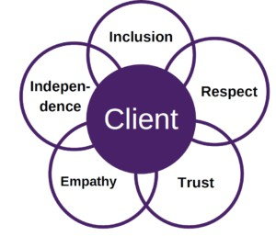

BALANCE provides customized training and support to facilitate optimal independence and community engagement for persons who are blind or living with sight loss and who often have complex needs.

4

### Impact

Unique Individuals Served

# *174*

Group Sessions

# *195*

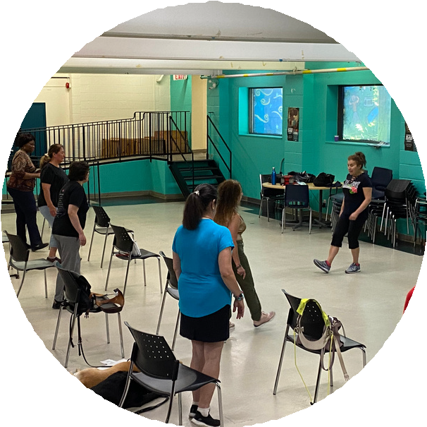

New Intakes

# *49*

Total Client Visits

# *1503*

Group Participants

# *69*

5

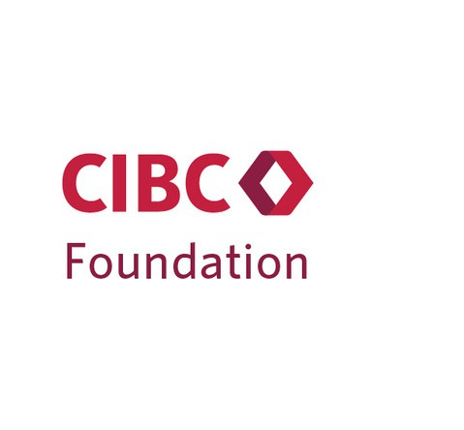

**Assistive Technology Apprenticeship Program**

Launched in late 2020, the (AT) Apprenticeship Program is designed to enhance technology skills and provide a paid employment experience for individuals with visual disabilities, while increasing the variety of teachers to meet the diverse needs of our adult learners. By March of 2024, the program had 5 apprentices and 4 graduates. This initiative has significantly improved job prospects for people with visual disabilities. In addition to developing technical skills, the ATAP helps apprentices build their own and the client’s confidence with using a variety of different technologies.

We extend our gratitude to our sponsors: HumanWare, CIBC Foundation, and Industrial Alliance Financial, for their invaluable support in making this program possible.



6

### Pre-employment Program (PEP)

Blind and partially sighted job seekers face unique challenges in their search for meaningful employment. That's why BALANCE, with funding support from the United Way of Greater Toronto, launched an innovative Pre-employment Program (PEP) in 2023. Designed to build the capacity and workplace confidence of adults with visual disabilities, we are so proud of the graduates who have moved through the program this past year. With our PEP workshop being offered via Zoom, we are now looking to expand the initiative and serve jobseekers beyond the City of Toronto. As a part of our inclusivity and accessibility efforts, we also provided five employment agencies with inclusivity training and provided advocacy with six organizations. The Pre-employment Program is truly an innovative initiative working that is changing lives!

"I’m excited. It's the first time in [years] I'll be getting a real paycheque - and it feels good". Summer 2023 PEP graduate

Tom Dekker Assistive Technology Achievement Awards

We are honored to announce this year’s recipients of the Tom Dekker Assistive Technology (AT) Award. This award recognizes BALANCE AT participants who show strong motivation, dedication, and determination in using assistive technology. Selected by the entire AT team, including our dedicated apprentices, this year's recipients were:

***Candise Arima***, who is partially sighted and has shown remarkable determination learning to use tools like Zoom magnification, Speak on touch, Hover text, Read aloud, and Be My Eyes.

***Saba Webb,*** who is blind and has embraced AT, learning to use Windows 11 with the NVDA screen reader after being introduced to the iPhone. Her determination is outstanding.

THANK YOU TO UNITED WAY GREATER TORONTO 7

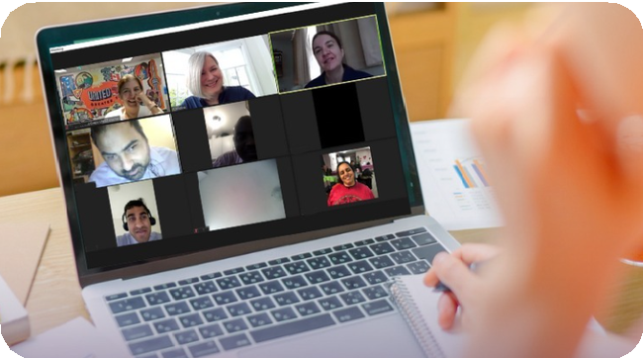

### Groups and Events

In 2023-24, we successfully organized 14 in-person and online groups, courses, and workshops. This year, BALANCE has provided opportunities to participate in-person or online group wellness activities such as Strength and Stability, Think outside the Ring – Boxing workshop, Evening Stress and Resilience Management and our Sharing Space Support Group. Another key goal of BALANCE is to deliver high-quality services in alignment with our one-to-one programs, aimed at enhancing clients' skills. This commitment is evident through workshops like Introduction to Spoken Word, and the Musical Theatre Movement Workshop.

Thank you to our partners in providing these groups:

Vibe Arts, Toronto News Girls – Savoy Howe, Davenport-Perth Community Neighborhood Centre and BALANCE Counsellors. We would also like to recognize 4 Villages and West Neighborhood House for providing a safe and inclusive space to facilitate these workshops.

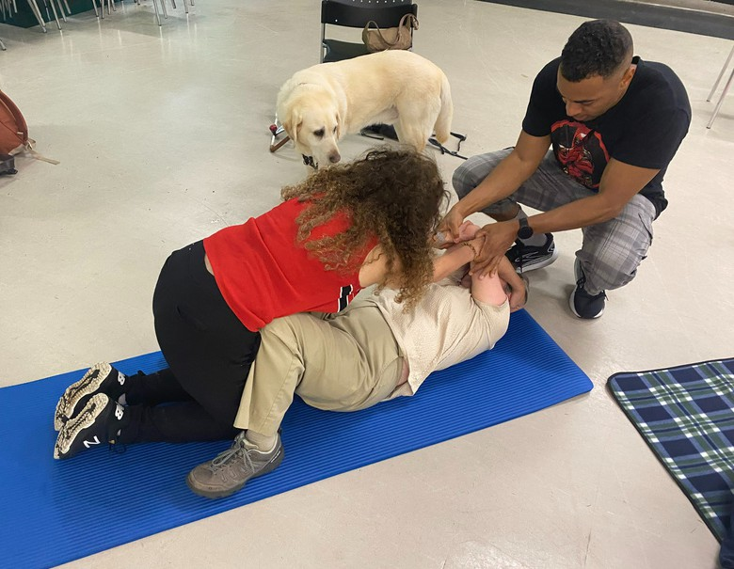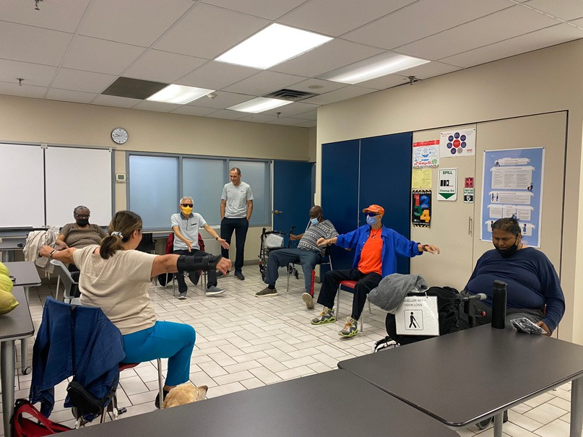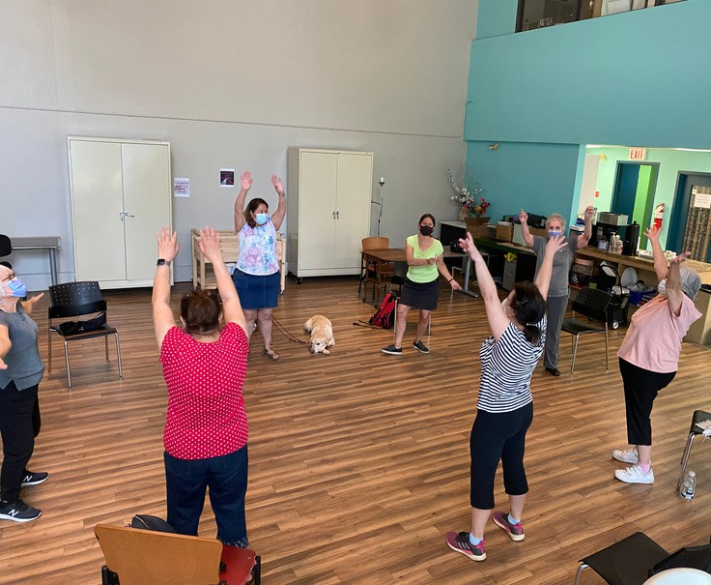

8

### Canadian National Exhibition Goose Up

***“BoB the Goose gains more independence as he gets his white cane to get to the Ex”***

The Canadian National Exhibition 2023 paid tribute to a Toronto icon: the Canada Goose. Eight GTA organizations for individuals with diverse abilities creatively transformed the white 6-ft tall fiberglass goose structure, into magnificent pieces of art. BALANCE was thrilled to be chosen to partake in this incredible project again in the summer of 2023.

BoB (stands for Because of BALANCE) is a 6 foot purple, grey and white goose who wears glasses and uses a white cane for enhanced independence. In addition, BoB carries his tablet everywhere because his Assistive Tech lessons have helped him learn how to use it to access information about his flock’s activities and whereabouts. BoB always wears his glasses and wears his heart (the BALANCE “B” heart of course) on his sleeve, for all to see how much he loves the services we provide.

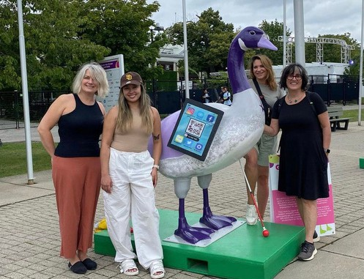If you know someone like BoB who is living with sight loss and wanting to build more independence or get out into the community, have them contact BALANCE for Blind Adults. Just tell them BoB sent you!

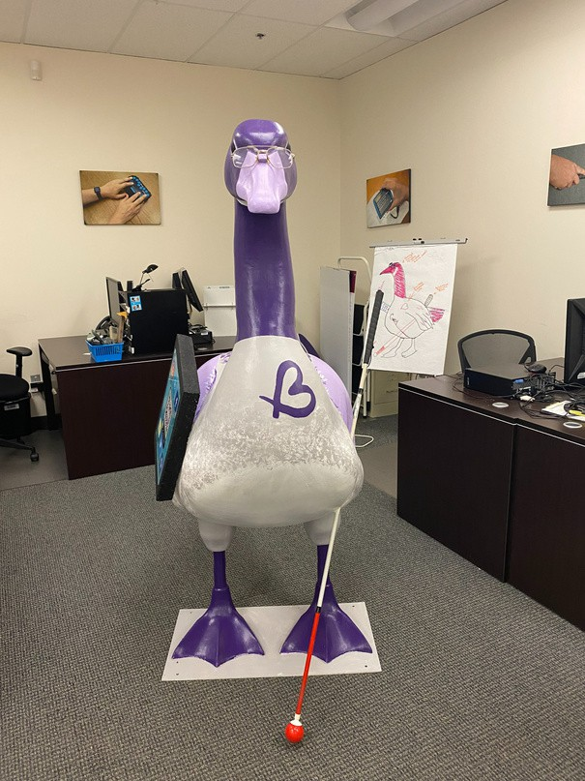

9

### BALANCE INFO Fair

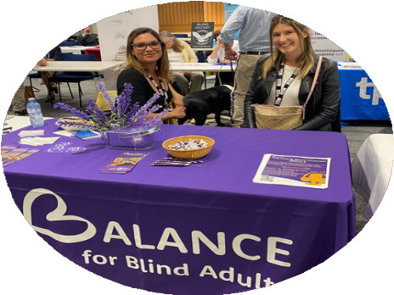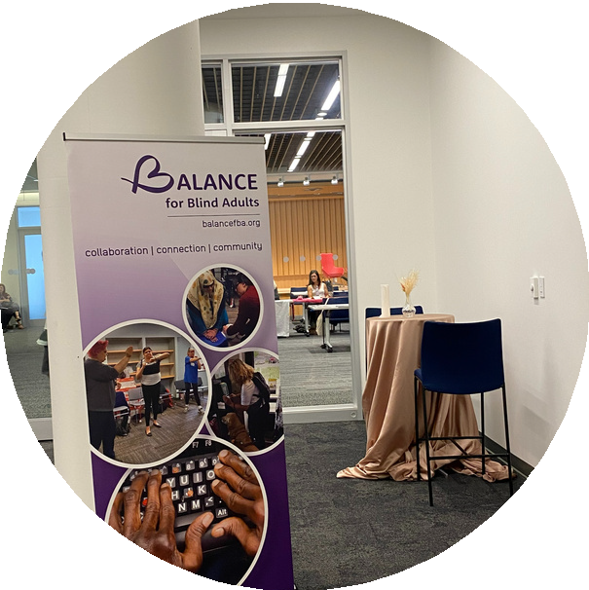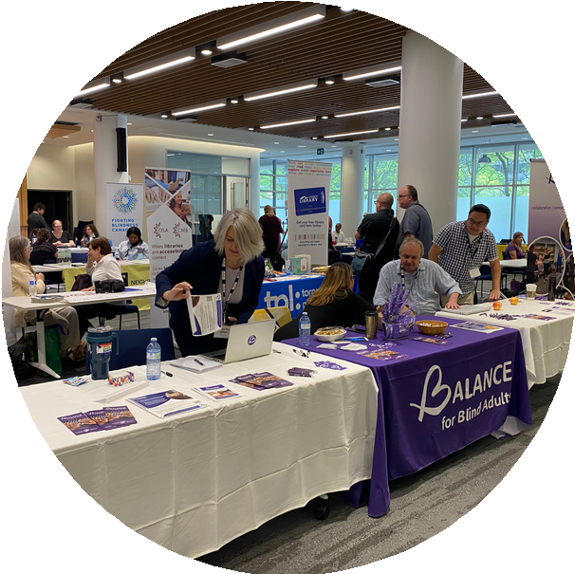

After over four years, the BALANCE Community Info Fair made its much-anticipated return, providing a unique in-person opportunity in a wonderful new space for individuals with visual disabilities to connect with each other, product vendors, and service providers. Held on September 29, 2023, at the Toronto Public Library - North York, the event was a significant success.

Twenty-nine exhibitors showcased a diverse range of products and services designed to support individuals with visual disabilities. The fair attracted 70 attendees, fostering a dynamic and interactive environment. In addition, 6 special talks were conducted, providing valuable insights and information on various topics pertinent to the community. Our Fair Sponsor, Accessible Media Inc. (AMI), broadcasted live from the event, interviewing a selection of exhibitors; this significantly increased engagement and visibility.

The return of the Info Fair was indeed a resounding success. It created a unique platform for networking and resource-sharing among individuals with visual disabilities. The positive turnout and enthusiastic participation underscore the importance of such events in our community. We look forward to future events to continue to build on this success.

10

### Low Vision Speaker

**Series**

Our first annual Low Vision Speaker Series presented by Eye Recommend was a huge success. With over 170 optometrists and low vision specialists in attendance at our no-cost, three-part virtual event, taking place in April and May, we knew this would become an important event for BALANCE. Along with our sponsors, we were pleased to invite Dr. Keith Gordon, Dr. Ana Juricic, and Dr. Tammy LaBreche as speakers, discussing Charles Bonnet Syndrome, wearable digital technology, and driving with bioptics.

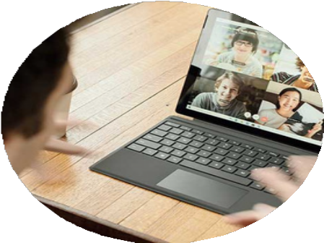

11

Each talk was well attended and 95% of optometrists and other low vision professionals in attendance stated they had not heard of BALANCE before. Thus, goal achieved- we raised so much awareness! In addition to awareness, this important new event series raised a total of $13,100 to support our programs and services.

Connecting with vision care professionals is a key to unlocking the door to our supports for optometry patients with visual disabilities. Please look out for the Low Vision Speaker Series coming with new topics and new speakers annually in May!

### Living Blind Podcast

**9** EPISODES

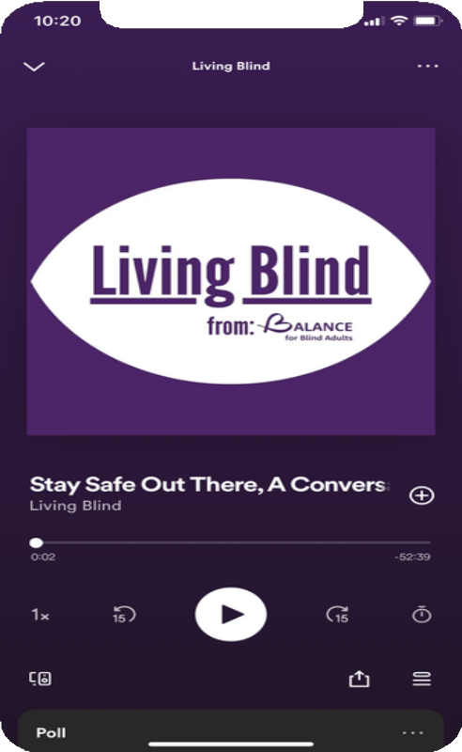

## 5,903

**32%**

PLAYS

AVERAGE LISTENERS FROM CANADA

12

### Because of BALANCE Campaign 2023

Our 5th annual Because of BALANCE campaign was another resounding success! Together, 33 clients, volunteers, staff, and

board members shared their stories of how BALANCE has

changed

$40,000

their

lives. And together we collectively raised

to

support

BALANCE's

incredible

programs

and

services. We remain grateful to our anonymous matching donor who matched EVERY single donation this year! We hope you'll

join us again.

13

**Volunteers Make a Difference!**

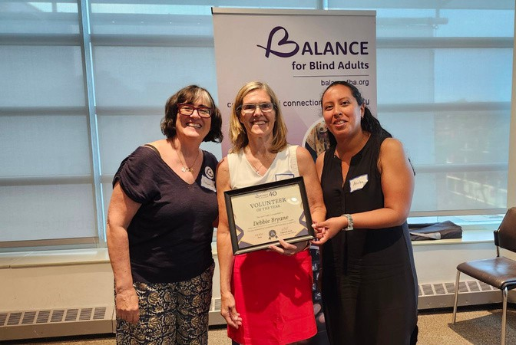

BALANCE for Blind Adults is fortunate to have a strong team of volunteers who provide service on a regular basis to our organization. This past fiscal year, we had 16 dedicated volunteers assist in a range of roles. To celebrate our volunteers who selflessly provide support to BALANCE for Blind Adults, we are introducing our first ever Volunteer of the Year award for outstanding service and contributions to our organization. The first recipient of this award is Debbie Byrane! Debbie has played an important part in delivering services to our clients in a variety of ways, including actively participating in our Because of BALANCE Campaign each fall, and, assisting our clients at the weekly musical movement program. In addition, she has shown commitment and creativity with her annual knitting fundraiser project. Thank you for all that you have done for our clients through these many ways of volunteering your time and creativity to our organization! This award is so very well deserved. Congratulations Debbie.

14

### Funding Partners

#### *Grants:*

*The George Lunan Foundation EKATA Foundation*

*iA Financial*

[*EnAbling Change Program*](https://balanceforblindadults.lightning.force.com/lightning/r/0065f00000M0b7xAAB/view) *- Ministry for Seniors and Accessibility United Way Greater Toronto*



*CIBC Foundation*

*YPI - Youth and Philanthropy Initiative* [*LiUNA Local 183*](https://balanceforblindadults.lightning.force.com/lightning/r/0015f0000193XiaAAE/view)

*Toronto Foundation*

#### *Corporate:*

15

16

**NEW COMMUNITY PARTNERS \***

### Community Partners

Thank you to all of our 2023 - 2024 community partners.

4 Villages Community Health Centre ABC Life Literacy

Access Employment Accessible Media AEBC

Bachelor of Social Work Program

**Brands for Canada\***

CCB National

CCB Toronto Visionaries

Centre for Independent Living Toronto CILT

City of Toronto

CNIB- Come to Work Program Common Boots Theatre CommunitiCare Health Community Workers

COSTI

**CultureLink Settlement and Community Services\***

Davenport-Perth CHC

Fighting Blindness Canada (FBC) George Brown College Department of Accesible Learning Services

Humber College department of Social & Community Services

**Jumpstart refugee Access Employment* March of Dimes, Skilling Up\***

**SD Free Self Defense-Chris James\*** St. Stephen's Community House Storefront Humber

Toronto Metropolitan University,

**Toronto New Girls\***

Toronto Public Health

**University of Toronto, Blueprint Career Services\***

**University of Toronto, Department of Computer Science\***

University of Toronto, Occupational Therapy

University of Toronto, School of Continuing Studies

Vibe Arts

Vision Loss Rehabilitation Ontario Volunteer Toronto

West Neighbourhood House

West Toronto Ontario Health Team Woodgreen Housing Help Centre **York U Accessibility Office W Ross MacDonald\***

### Thanks to:

***Staff***

**Dr. Deborah Gold** *Executive Director*

**Doug Poirier** *Assistive Technology Lead*

**Ronashelle Coro** *Office and Communications Coordinator* **Bill Phung** *Certified Orientation and Mobility/ Data Specialist* **Cristina Lopes** *Program Coordinator and Community Engagement Services Specialist*

**Christina Peruzzi** *Pre-Employment Program Coordinator* **Olivia Pietrzyk** *Adaptive Daily Living Skills Instructor* **Kiana Raeesdana** *Orientation and Mobility Instructor* **Windy Ho-Li** *Assistive Technology Instructor*

**Meredith Poirier** *Summer Youth Office Assistant*

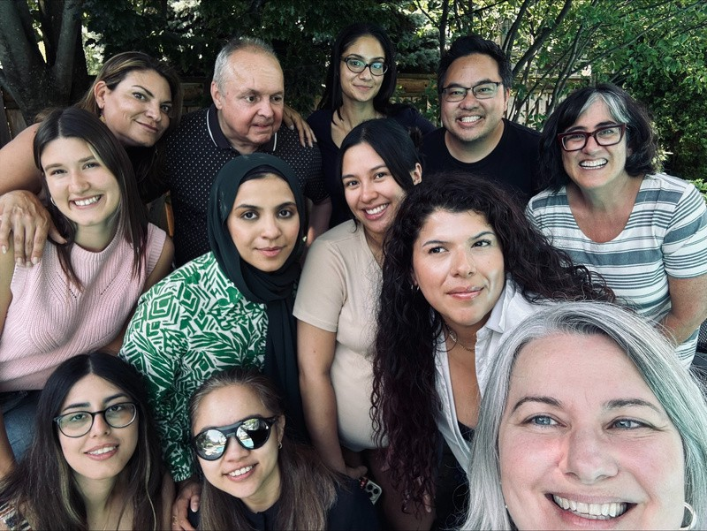

17

### Staff Continued

##### *Contractors:*

**Naomi Hazlett** *Podcast Host* **Jeffrey Rainey** *Podcast Producer* **Lisa Derencinovic** *Counsellor* **Melanie Marsden** *Counsellor*

**Anita Laurnitus** *Volunteer Coordinator*

##### *Students:*

**Sujin Lee Nursing** *Placement Student*

##### *Marketing and Fundraising:*

**Beverley Murray** *Grant Writer*

**Deanna Carruthers** *Development Officer*

**Amanda Race** *Grant Writer*

**Sandy Feldman** *Website Developer*

**Margrett Weldon** *Client Satisfaction Surveyor*

##### *AT Apprentices:*

Diana Horani Kim Harbroe Laurisa White

Victoria Hernandez Joseph Sidarose

Jay Risman 18

### Board of Directors

Keith Gordon *Board Chair* Robin Dafoe *Vice-Chair* Michelle McQuigge *Past Chair* Marcus M. Song *Treasurer* Virginia Duff *Secretary*



Jeevan Bains *Board Member*

Alex Bulmer *Board Member* Martin Courcelles *Board Member* Gillian Davis *Board Member*

Ana Juricic *Board Member*

Jue Li *Board Member*

Lizna Husnani-Puchta *Board Member*

Stephen Ricci *Board Member*

Bob Stark *Board Member*

Meenakshi Venkatesan *Board Member*

Wayne Yeung *Board Member*

19

### Condensed Financial Statement

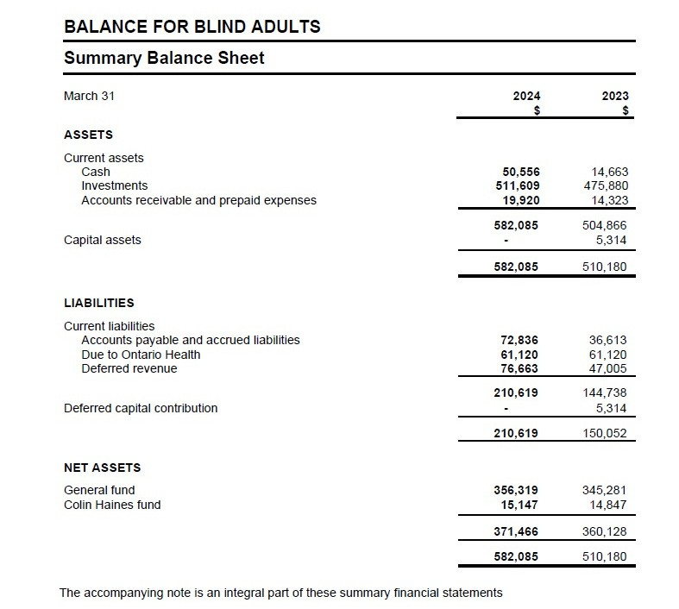

20

**Condensed Financial Statement**

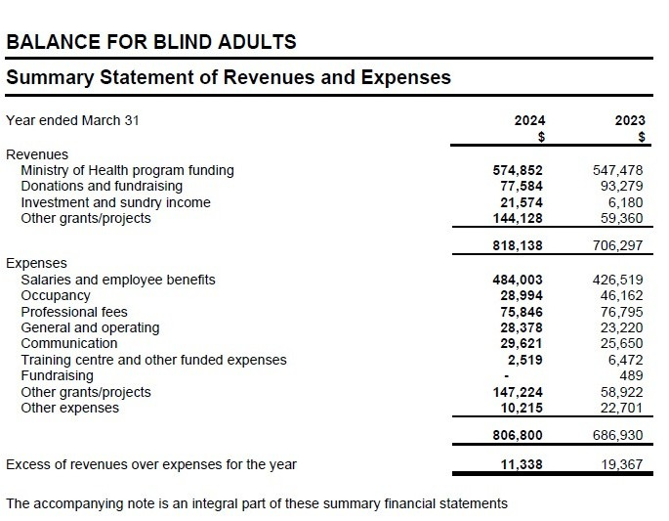

21

### 2023-2024 Donors

###### “Our heartfelt thanks to our 2023-2024 donors”

Adam Growe Adela Mall

Agathaa Garcia-Wright Akeem Sulaimon Allan Lacap

Amanda Yao Amelia Ortiz Ana Juricic Anar Samji

Andrew and Dani Salomon Angela Galli

Anita Laurnitus Anna Gold Anna Kan Anna Rago Anna Zyblock Anne Fair

Anne Musgrave

Anne Stokes Ari Goldkind

Audrey Vermeer Barbara Bulmer Beryl Grant-Duffus Betty Gindi Beverley Murray Bob Biggs

Carolyn James Horton

Carolyn Stark Cassandra Brown Catherine Tardif Chester Lee Christina Peruzzi Clarence Baker Collin Jarvis Daliah Chapnik

Daniella Levy-Pinto

David Bryane David Cohen David Gotlib

22

### 2023-2024 Donors

###### “Our heartfelt thanks to our 2023-2024 donors”

Deanna Carruthers Deanna Choi Debbie Bryane Debra Horsfield Deepshikha Guleria Diane Juzkow

Dina McCaw

Donnabelle Dihan Dorothy de Val Doug Poirier Doyin Obiki

Edith Ho Elaine Tamura Eleanor Ballett

Eleanor Lobo-Lee Elisa Cardilli Ellen Yamasaki Enemona Itodo Erica Yao

Euselda Altamirano

Firoz Kara Frances Lau

Francesca Eluromma Gaby Sedra

Gil Dodick Ginny Duff

Glendon Singleton-Wood Graham Brown Harsimran Rattan

Harvinder and Seema Puri Heather Harrison

Heino Nielsen Howard Gotlib Ian Bryane Ilya K.

Isaac Berman Ivan Cheuk Ivan Tom Jagjit Singh James Brazill

23

### 2023-2024 Donors

###### “Our heartfelt thanks to our 2023-2024 donors”

James Riley Janet Sweatman Janine Mckeown Jann Migel Asilo Jeannine Allot Jeevan Bains Jeffrey Rainey Jennifer Abbott

Jennifer Wentworth

Jeremy Gibbens Jessica Thompson Jessica Vorstermans Jill Rich

Joel Gold

John and Barbara Gambles John McCleary

John Tomasino Joseph Hanna Julia Foster Keddy Williams

Keith Gordon Kerstin Lueck Kristin Chong Larissa Gonsalves Laurie Brager Leeann Thompson Lesley Inglis

Lisa Hamather

Lorne Berman Maddie Bennett Madhuri Rajani Madiha Master Magdalene Li Manan Pandit Margaret Keenan Margaret Nott Margaret Williams Maria Buzdon Maricel Malimban Mark Stubbings

24

### 2023-2024 Donors

###### “Our heartfelt thanks to our 2023-2024 donors”

Marrianne Bridge Martin Copeland Mary Ann Oughtred Matthew Silver Melanie Archambault Michael Shiu Michelle Chong Michelle Grasso

Micky Fraterman-Oostra

Mihika Kelkar Mireille El Mounzer Mireille Moun Murli Iyer

Nancy Slater Naomi King Nick Svab

Olamiposi Olawole Olohigbe Iruobe Oluwabukola Agbede Onyi Okenu

Pamela Isaak Paul Grossman Peter Hanna Poonam Gawri Puneet Kaur Quan Gan Rachel Berman Rahul Kaul Richard Choi Rita Taricani Robert Hall Roberta Clough Robin Dafoe Rocchina Morra Rolando Sy Rustom Satchu Ryle Gonsalves Saidat Lawal Sam Bucovetsky Sandhya Anugopal

25

### 2023-2024 Donors

###### “Our heartfelt thanks to our 2023-2024 donors”

Sandra Gold Sandy Feldman Sandy Lee Seye Ologunja

Zehra Seyhun

Plus many anonymous donors!

26

Shirley O'Donnell Simran Kaur

Sisi L. Steve Pinto

Sue Traynor Susan Bedford Susan Eason

Teresa Horner-Quiroz Theodore Greenberg Tiffany Antosz Vanessa Bourget Viktoria Khan

Wendy Hymes

William Fearn William Stark Zaid Rawni

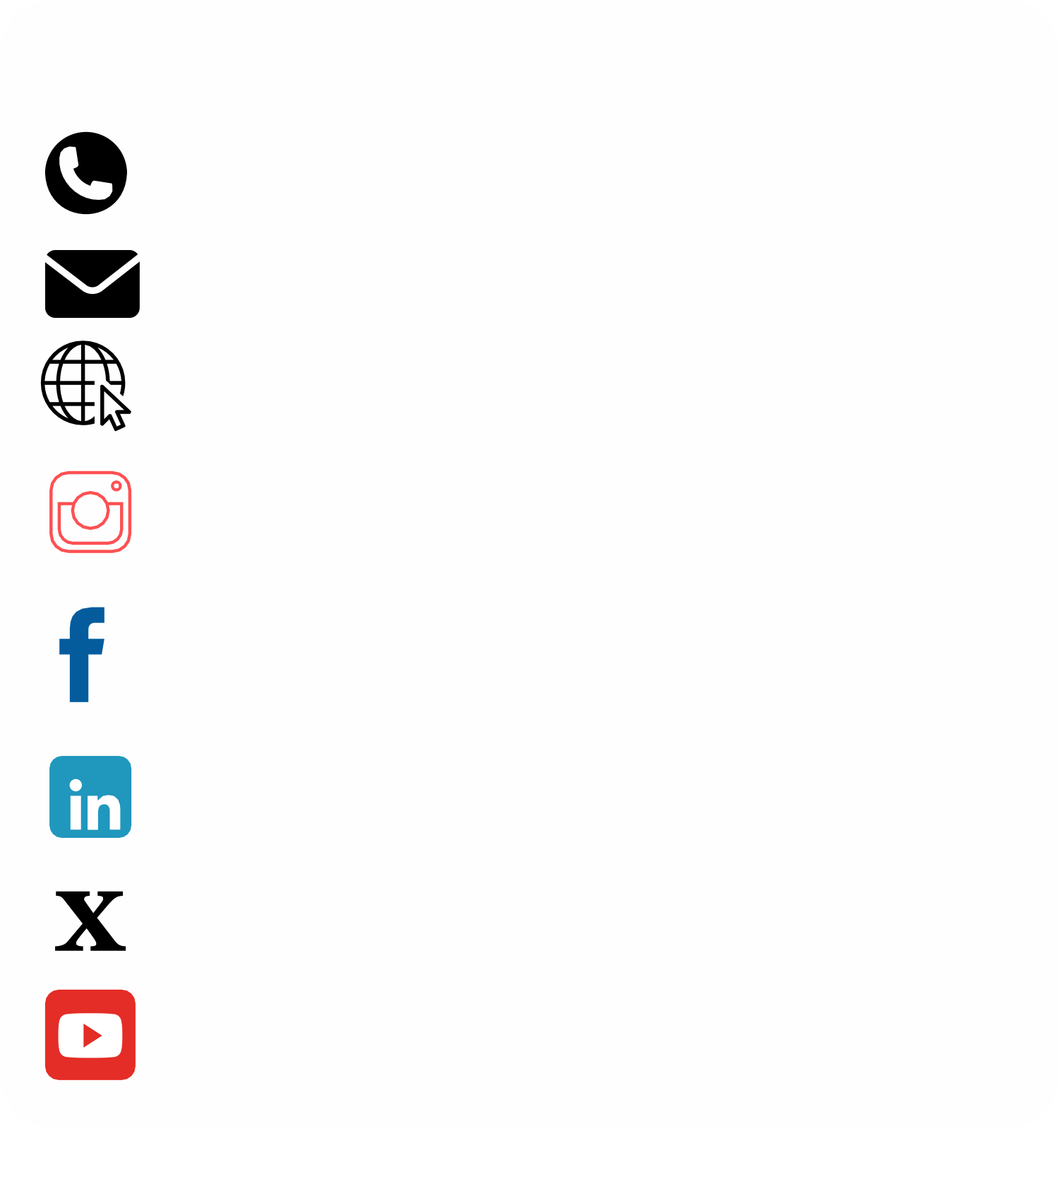





## Connect with us!

**416-236-1796**

[**info@balancefba.org**](mailto:info@balancefba.org) **balancefba.org @balanceforblindadults**

**@balanceforblindadults @BALANCE for Blind Adults @balancefba**

**BALANCE for Blind Adults**

27